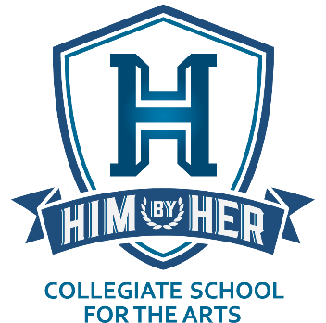
HIM By HER Collegiate School for the Arts
4501 East 32nd Street • Indianapolis, IN 46218 Phone: (317) 918-7799 • Email: info@himbyherschool.org
Website: www.himbyherschool.org

PUBLIC NOTICE OF SCHOOL BOARD MEETING

DATE: SATURDAY, January 09, 2021
TIME: 11:30 A.M.
WHERE: THE HIM BY HER BUILDING
4501 EAST 32ND ST., INDIANAPOLIS, IN 46218

To Members of the Public and all HIM By HER Collegiate School for the Arts Stakeholders:

Please take note that the Board of Directors for the HIM By HER Collegiate School for the Arts (HBHCSA) will hold a Meeting on Saturday, December 9, 2021 at 11:30 a.m. at the HIM By HER Headquarters and School Building located at 4501 East 32nd Street, Indianapolis, Indiana 46218.
The general public is welcome and encouraged to attend, as are all HBHCSA Stakeholders (students and families, school personnel, donors, members of the public).

Esteemed HIM By HER Collegiate School for the Arts Board Members:

Please remember the HIM By HER Collegiate School for the Arts (HBHCSA) Board Meeting on Saturday, January 9, 2021 at 11:30 a.m., at 4501 East 32nd Street, Indianapolis, Indiana 46218. Again, the Board meetings are the first Saturday of every month unless otherwise indicated. Recall that the January meeting was moved to January 9th because of the holiday weekend had it occurred on the 2nd. Should you not be able to attend physically, please use the following information to remotely participate: Telephone call-in number: (425) 436-6260; Access code: 9155363.
The Meeting Agenda is as follows:

Call to Order and Chairman's Remarks
Secretary's Report
Treasurer's Report
President's Report
Old Business
New Business
Setting of the Next Meeting
Meeting Adjournment

* * *

Yours Truly,

Gregory P. Gadson, Corporate Secretary
HIM By HER Foundation, Inc.
gregory_gadson@yahoo.com
(317) 965-9609

Please note that we will be observing important pandemic guidelines during the meeting, including mask wearing and social distancing.

6 ft.

